# Friction Concept

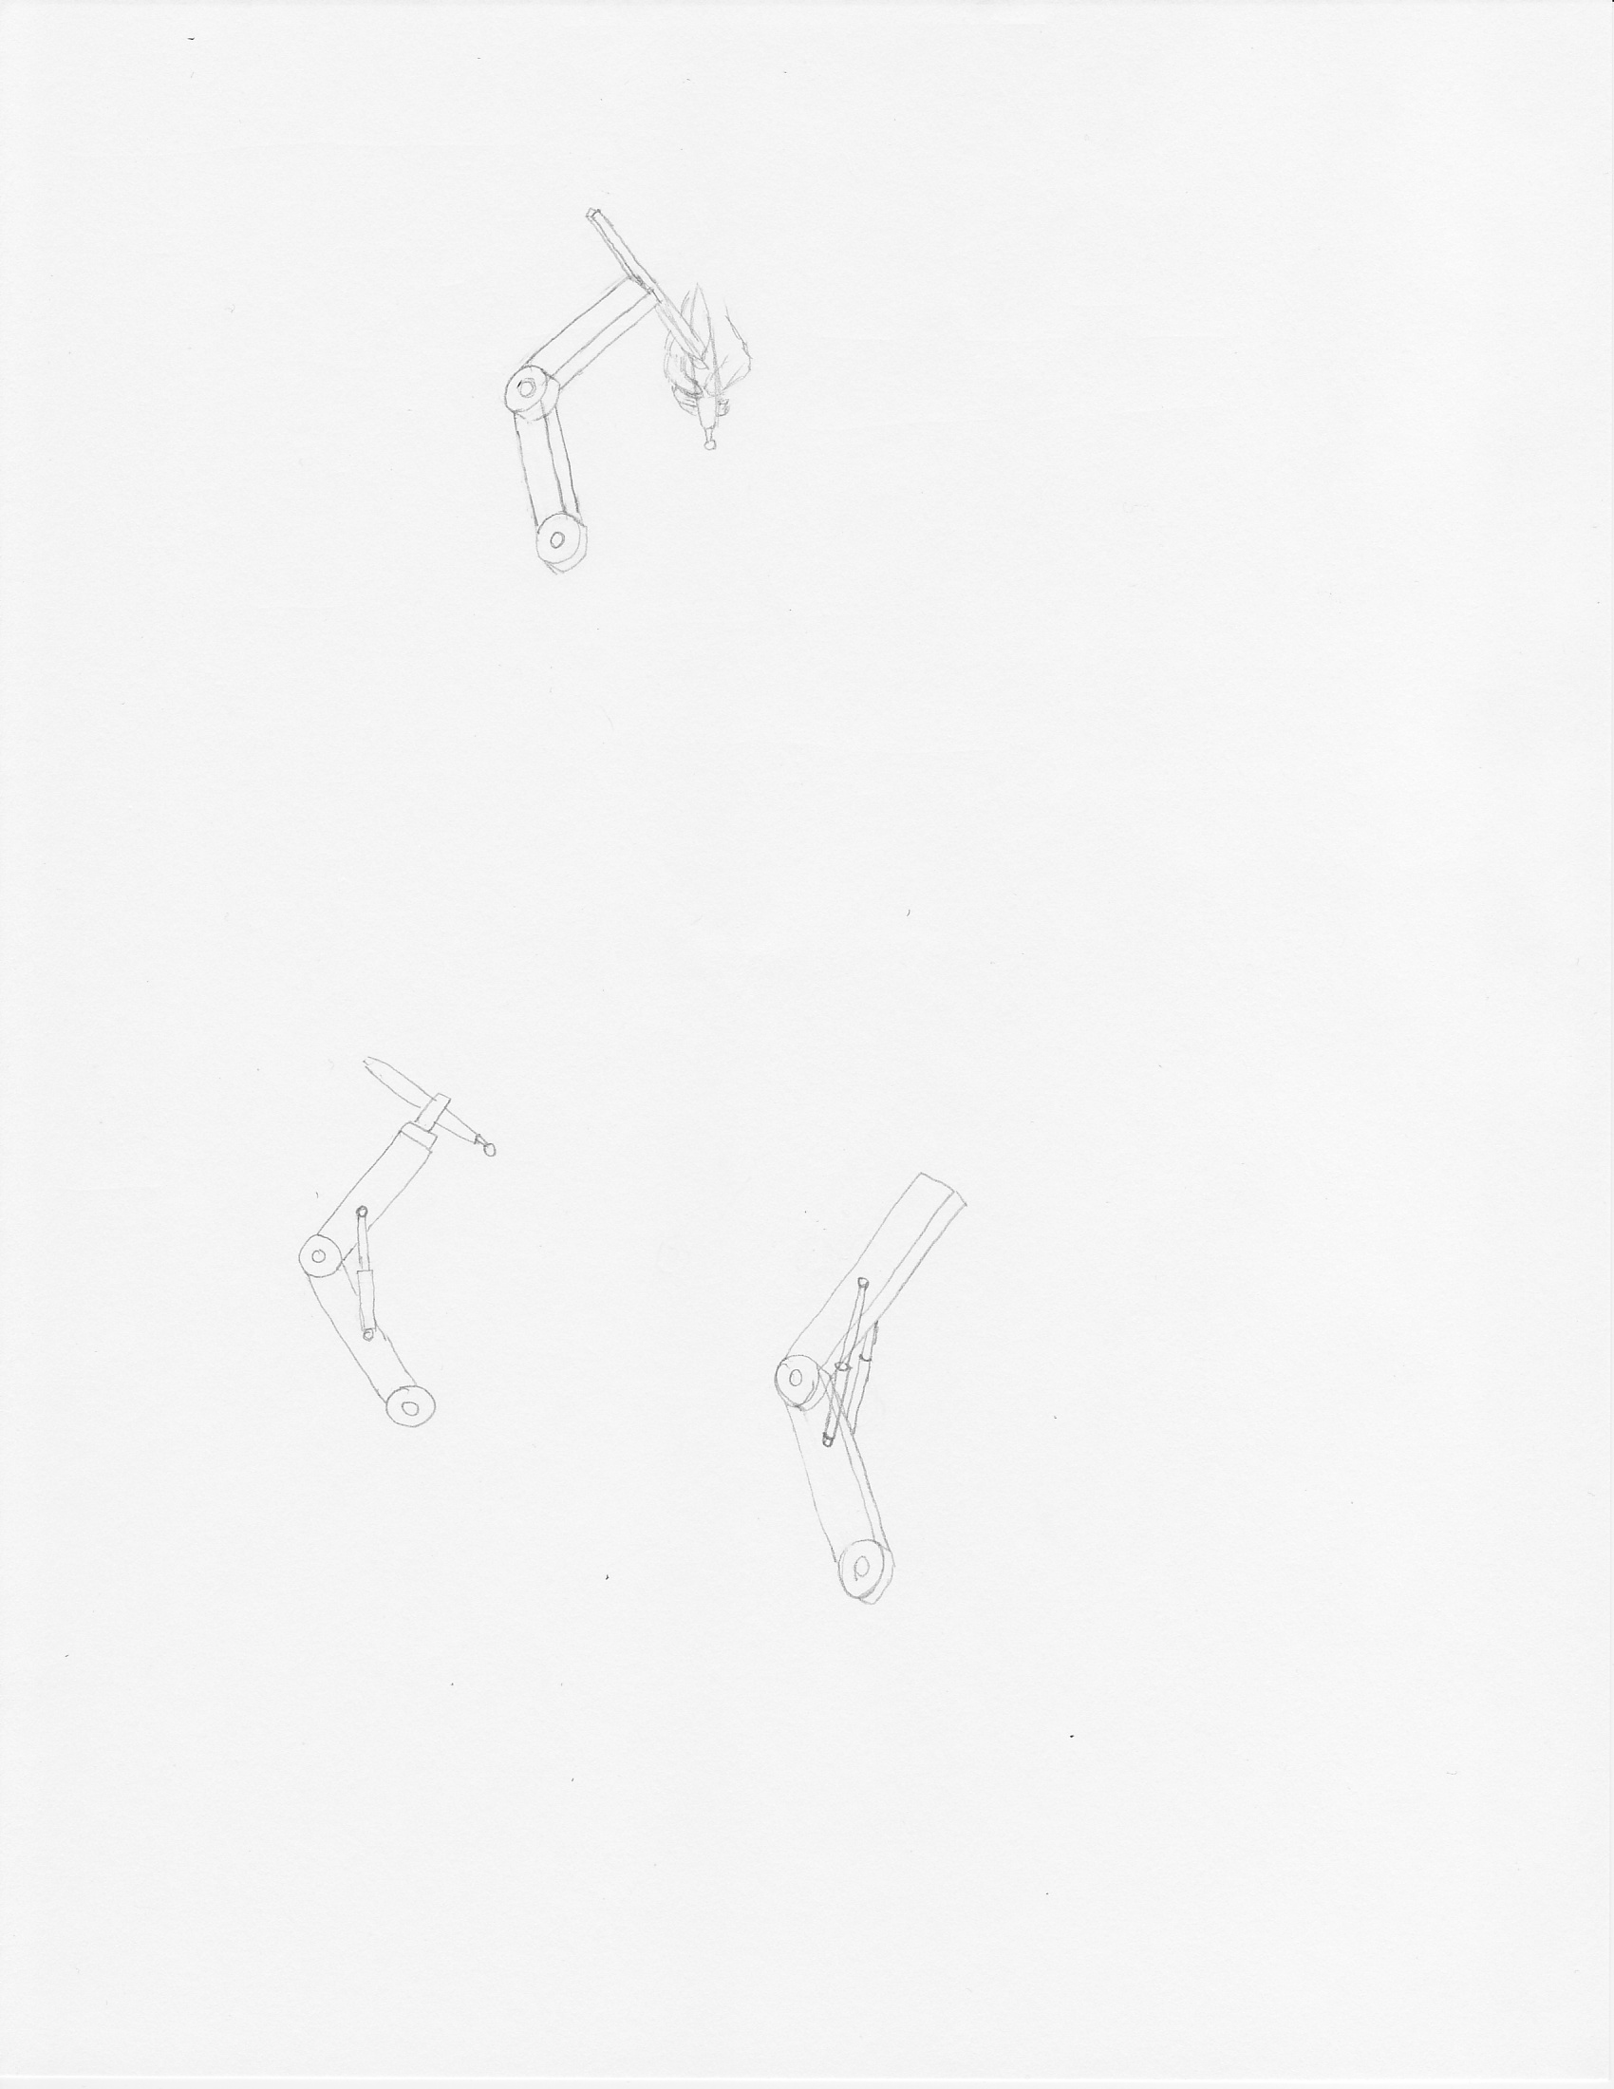

In this concept, the joints in the linkages have materials chosen with a coefficient of friction that produces a friction force to prevent the device from falling under its own weight.

There are obvious disadvantages with this design. As a consequence of maintaining the position of the device, it imposes additional virtual weight that the user must overcome when trying to reposition it. The momentum from the force required to put it into motion can result in moving past the desired location. This may not be acceptable in a surgical setting. In addition, it is unidirectional, meaning that it only reduces the virtual weight moving down. When moving up, the user now must overcome the weight of the device and additional friction. Also, using different tools with different weights will require the joints to be readjusted.

However, it has advantages in that it is very simple, easy to implement and has no issues with sterilization. It is also a passive solution, which means it is unpowered and will remain in position with no input.

# Damper Concept



Hydraulic dampers are attached to the linkages to resist the force of gravity by damping the pivotal motion around the joint.

The most concerning disadvantage with this concept is that sterilization is not easily achievable due to the shaft of the hydraulic damper being exposed in a surgical environment. Similar to the high friction joint concept, this also creates additional virtual weight needed for repositioning of the device. Since moving the device up requires the user to overcome both the weight and the damper, it is also unidirectional.

An advantage this concept has is that it can be implemented with either passive or active controls. The actively controlled dampers would use sensors to adjust them to reduce virtual weight. Relative to the complexity of the other concepts, this concept would be low complexity for passive and high complexity for active.